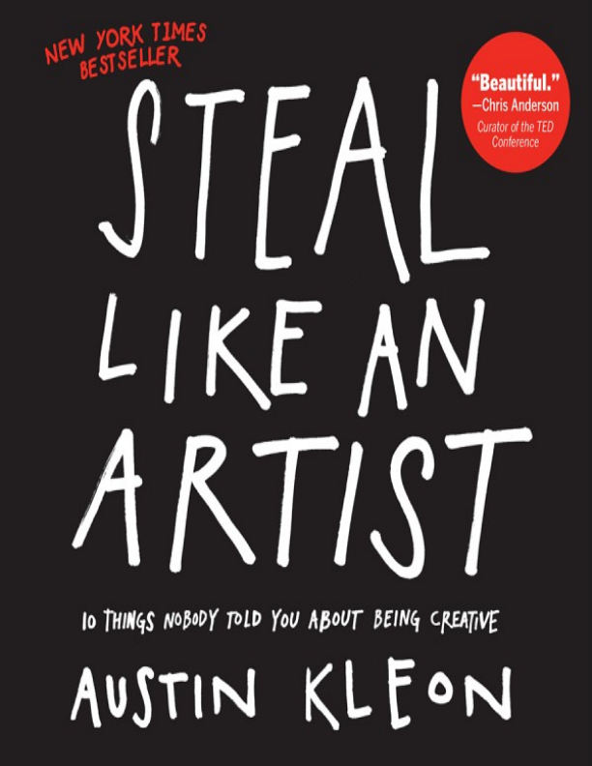
Steal Like an Artist 10 Things Nobody Told You About Being Creative
Austin Kleon
WORKMAN PUBLISHING COMPANY • NEW YORK
For Boom—whenever Boom gets here
CONTENTS
1. Steal Like an Artist.
2. Don’t Wait Until You Know Who You Are to Get Started. 3. Write the Book You Want to Read.
4. Use Your Hands.
5. Side Projects and Hobbies Are Important.
6. The Secret: Do Good Work and Share It with People. 7. Geography Is No Longer Our Master.
8. Be Nice. (The World Is a Small Town.)
9. Be Boring. (It’s the Only Way to Get Work Done.) 10. Creativity Is Subtraction.
“Art is theft.” —Pablo Picasso
“Immature poets imitate; mature poets steal; bad poets deface what they take, and good poets make it into something better, or at least something different. The good poet welds his theft into a whole of feeling which is unique, utterly different from that from which it was torn.”
—T. S. Eliot
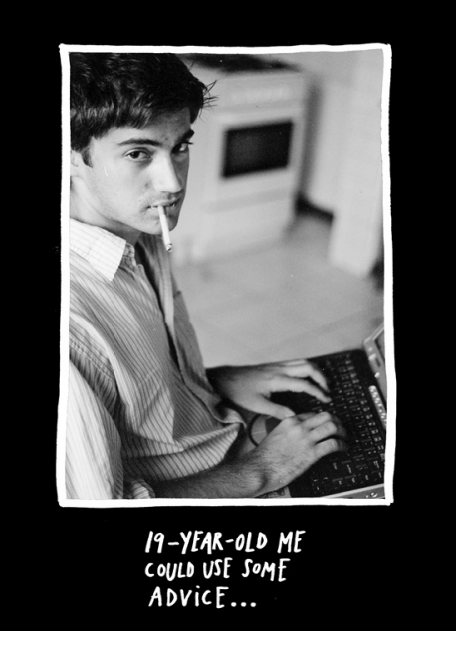
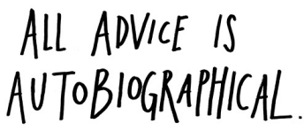
It’s one of my theories that when people give you advice, they’re really just talking to themselves in the past.
This book is me talking to a previous version of myself.
These are things I’ve learned over almost a decade of trying to figure out how to make art, but a funny thing happened when I started sharing them with others—I realized that they aren’t just for artists. They’re for everyone.
These ideas apply to anyone who’s trying to inject some creativity into their life and their work. (That should describe all of us.)
In other words: This book is for you.
Whoever you are, whatever you make.
Let’s get started.
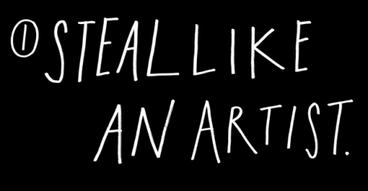
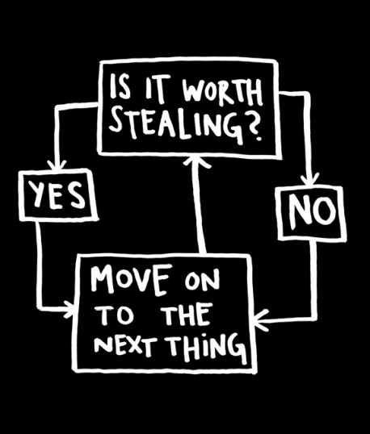
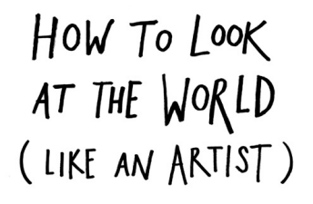Every artist gets asked the question,
“Where do you get your ideas?”
The honest artist answers,
“I steal them.”
How does an artist look at the world?
First, you figure out what’s worth stealing, then you move on to the next thing.
That’s about all there is to it.
When you look at the world this way, you stop worrying about what’s “good” and what’s “bad”—there’s only stuff worth stealing, and stuff that’s not worth stealing.
Everything is up for grabs. If you don’t find something worth stealing today, you might find it worth stealing tomorrow or a month or a year from now.
“The only art I’ll ever study is stuff that I can steal from.” —David Bowie
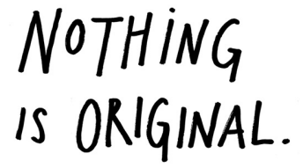
The writer Jonathan Lethem has said that when people call something “original,” nine out of ten times they just don’t know the references or the original sources involved.
What a good artist understands is that nothing comes from nowhere. All creative work builds on what came before. Nothing is completely original.
It’s right there in the Bible: “There is nothing new under the sun.” (Ecclesiastes 1:9)
Some people find this idea depressing, but it fills me with hope. As the French writer André Gide put it, “Everything that needs to be said has already been said. But, since no one was listening, everything must be said again.”
If we’re free from the burden of trying to be completely original, we can stop trying to make something out of nothing, and we can embrace influence instead of running away from it.
“What is originality? Undetected plagiarism.”
—William Ralph Inge
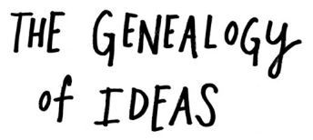
Every new idea is just a mashup or a remix of one or more previous ideas.
Here’s a trick they teach you in art school. Draw two parallel lines on a piece of paper:
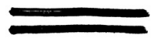
How many lines are there?
There’s the first line, the second line, but then there’s a line of negative space that runs between them.
See it? 1 + 1 = 3.
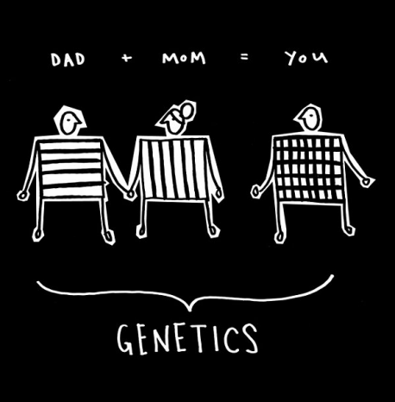
A good example is genetics. You have a mother and you have a father. You possess features from both of them, but the sum of you is bigger than their parts. You’re a remix of your mom and dad and all of your ancestors.
Just as you have a familial genealogy, you also have a genealogy of ideas. You don’t get to pick your family, but you can pick your teachers and you can pick your friends and you can pick the music you listen to and you can pick the books you read and you can pick the movies you see.
You are, in fact, a mashup of what you choose to let into your life. You are the sum of your influences. The German writer Goethe said, “We are shaped and fashioned by what we love.”
“We were kids without fathers . . . so we found our fathers on wax and on the streets and in history. We got to pick and choose the ancestors who would inspire the world we were going to make for ourselves.”
—Jay-Z
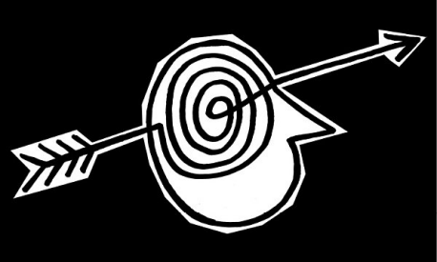
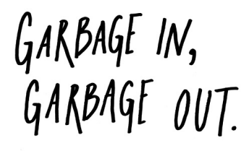
The artist is a collector. Not a hoarder, mind you, there’s a difference: Hoarders collect indiscriminately, artists collect selectively. They only collect things that they really love.
There’s an economic theory out there that if you take the incomes of your five closest friends and average them, the resulting number will be pretty close to your own income.
I think the same thing is true of our idea incomes. You’re only going to be as good as the stuff you surround yourself with. My mom used to say to me, “Garbage in, garbage out.” It used to drive me nuts. But now I know what she meant.
Your job is to collect good ideas. The more good ideas you collect, the more you can choose from to be influenced by.
“Steal from anywhere that resonates with inspiration or fuels your imagination. Devour old films, new films, music, books, paintings, photographs, poems, dreams, random
conversations, architecture, bridges, street signs, trees, clouds, bodies of water, light and shadows. Select only things to steal from that speak directly to your soul. If you do this, your work (and theft) will be authentic.”
—Jim Jarmusch
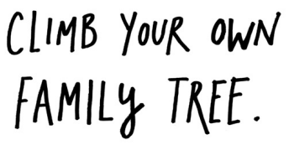
Marcel Duchamp said, “I don’t believe in art. I believe in artists.” This is actually a pretty good method for studying—if you try to devour the history of your discipline all at once, you’ll choke.
Instead, chew on one thinker—writer, artist, activist, role model—you really love. Study everything there is to know about that thinker. Then find three people that thinker loved, and find out everything about them. Repeat this as many times as you can. Climb up the tree as far as you can go. Once you build your tree, it’s time to start your own branch.
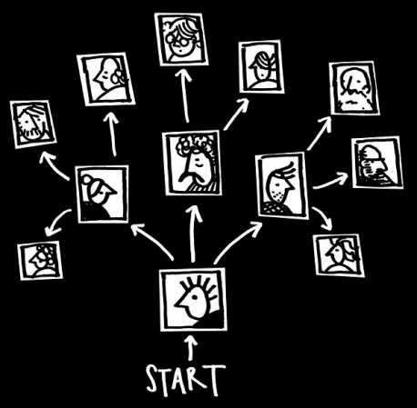
Seeing yourself as part of a creative lineage will help you feel less alone as you start making your own stuff. I hang pictures of my favorite artists in my studio. They’re like friendly ghosts. I can almost feel them pushing me forward as I’m hunched over my desk.
The great thing about dead or remote masters is that they can’t refuse you as an apprentice. You can learn whatever you want from
them. They left their lesson plans in their work.
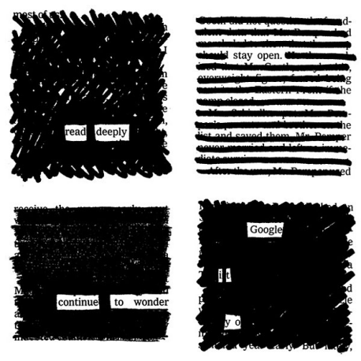
School is one thing. Education is another. The two don’t always overlap. Whether you’re in school or not, it’s always your job to get yourself an education.
You have to be curious about the world in which you live. Look things up. Chase down every reference. Go deeper than anybody else— that’s how you’ll get ahead.
Google everything. I mean everything. Google your dreams, Google your problems. Don’t ask a question before you Google it. You’ll either find the answer or you’ll come up with a better question.
Always be reading. Go to the library. There’s magic in being surrounded by books. Get lost in the stacks. Read bibliographies. It’s not the book you start with, it’s the book that book leads you to.
Collect books, even if you don’t plan on reading them right away. Filmmaker John Waters has said, “Nothing is more important than an unread library.”
Don’t worry about doing research. Just search.
“Whether I went to school or not, I would always study.” —RZA
Carry a notebook and a pen with you wherever you go. Get used to pulling it out and jotting down your thoughts and observations. Copy your favorite passages out of books. Record overheard conversations. Doodle when you’re on the phone.
Go to whatever lengths necessary to make sure you always have paper on you. Artist David Hockney had all the inside pockets of his suit jackets tailored to fit a sketchbook. The musician Arthur Russell liked to wear shirts with two front pockets so he could fill them with scraps of score sheets.
Keep a swipe file. It’s just what it sounds like—a file to keep track of the stuff you’ve swiped from others. It can be digital or analog—it
doesn’t matter what form it takes, as long as it works. You can keep a scrapbook and cut and paste things into it, or you can just take pictures of things with your camera phone.
See something worth stealing? Put it in the swipe file. Need a little inspiration? Open up the swipe file.
Newspaper reporters call this a “morgue file”—I like that name even better. Your morgue file is where you keep the dead things that you’ll later reanimate in your work.
“It is better to take what does not belong to you than to let it lie around neglected.”
—Mark Twain
If I’d waited to know who I was or what I was about before I started “being creative,” well, I’d still be sitting around trying to figure myself out instead of making things. In my experience, it’s in the act of making things and doing our work that we figure out who we are.
You’re ready. Start making stuff.
You might be scared to start. That’s natural. There’s this very real thing that runs rampant in educated people. It’s called “impostor syndrome.”
The clinical definition is a “psychological phenomenon in which people are unable to internalize their accomplishments.” It means that you feel like a phony, like you’re just winging it, that you really don’t have any idea what you’re doing.
Guess what: None of us do. Ask anybody doing truly creative work, and they’ll tell you the truth: They don’t know where the good stuff comes from. They just show up to do their thing. Every day.
Have you ever heard of dramaturgy? It’s a fancy term for something William Shakespeare spelled out in his play
As You Like It about 400 years ago:
All the world’s a stage,
And all the men and women merely players:
They have their exits and their entrances;
And one man in his time plays many parts.
Another way to say this? Fake it ’til you make it.
I love this phrase. There are two ways to read it:
1. Pretend to be something you’re not until you are—fake it until you’re successful, until everybody sees you the way you want them to; or
2. Pretend to be making something until you actually make something.
I love both readings—you have to dress for the job you want, not the job you have, and you have to start doing the work you want to be
doing.
I also love the book Just Kids by the musician Patti Smith. It’s a story about how two friends who wanted to be artists moved to New York. You know how they learned to be artists?
“You start out as a phony and become real.”
—Glenn O’Brien
They pretended to be artists. In my favorite scene, from which the book gets its title, Patti Smith and her friend, the photographer Robert Mapplethorpe, dress up in all their bohemian gypsy gear and go to Washington Square Park, where everybody’s hanging out. This old touristy couple is gawking at them. The wife says to her husband,
“Oh, take their picture. I think they’re artists.” “Oh, go on,” the husband disagrees. “They’re just kids.”
The point is: All the world’s a stage. Creative work is a kind of theater. The stage is your studio, your desk, or your workstation. The costume is your outfit—your painting pants, your business suit, or that funny hat that helps you think. The props are your materials, your tools, and your medium. The script is just plain old time. An hour here, or an hour there—just time measured out for things to happen.
Fake it ’til you make it.
“Start copying what you love. Copy copy copy copy. At the end of the copy you will find your self.”
—Yohji Yamamoto
Nobody is born with a style or a voice. We don’t come out of the womb knowing who we are. In the beginning, we learn by pretending to be our heroes. We learn by copying.
We’re talking about practice here, not plagiarism—plagiarism is trying to pass someone else’s work off as your own. Copying is about reverse-engineering. It’s like a mechanic taking apart a car to see how it works.
We learn to write by copying down the alphabet. Musicians learn to play by practicing scales. Painters learn to paint by reproducing masterpieces.
Remember: Even The Beatles started as a cover band. Paul McCartney has said, “I emulated Buddy Holly, Little Richard, Jerry
Lee Lewis, Elvis. We all did.” McCartney and his partner John Lennon became one of the greatest songwriting teams in history, but as McCartney recalls, they only started writing their own songs “as a way to avoid other bands being able to play our set.” As Salvador Dalí said, “Those who do not want to imitate anything, produce nothing.”
First, you have to figure out who to copy. Second, you have to figure out what to copy.
Who to copy is easy. You copy your heroes—the people you love, the people you’re inspired by, the people you want to be. The songwriter Nick Lowe says, “You start out by rewriting your hero’s catalog.” And you don’t just steal from one of your heroes, you steal from all of them. The writer Wilson Mizner said if you copy from one author, it’s plagiarism, but if you copy from many, it’s research. I once heard the cartoonist Gary Panter say, “If you have one person you’re influenced by, everyone will say you’re the next whoever. But if you rip off a hundred people, everyone will say you’re so original!”
What to copy is a little bit trickier. Don’t just steal the style, steal the thinking behind the style. You don’t want to look like your heroes, you want to see like your heroes.
The reason to copy your heroes and their style is so that you might somehow get a glimpse into their minds. That’s what you really want —to internalize their way of looking at the world. If you just mimic the surface of somebody’s work without understanding where they are coming from, your work will never be anything more than a knockoff.
“We want you to take from us. We want you, at first, to steal from us, because you can’t steal. You will take what we give you and you will put it in your own voice and that’s how you will find
your voice. And that’s how you begin. And then one day someone will steal from you.”
—Francis Ford Coppola
At some point, you’ll have to move from imitating your heroes to emulating them. Imitation is about copying. Emulation is when imitation goes one step further, breaking through into your own thing.
“There isn’t a move that’s a new move.” The basketball star Kobe Bryant has admitted that all of his moves on the court were stolen from watching tapes of his heroes. But initially, when Bryant stole a lot of those moves, he realized he couldn’t completely pull them off because he didn’t have the same body type as the guys he was thieving from. He had to adapt the moves to make them his own.
Conan O’Brien has talked about how comedians try to emulate their heroes, fall short, and end up doing their own thing. Johnny Carson
tried to be Jack Benny but ended up Johnny Carson. David Letterman tried to copy Johnny Carson but ended up David Letterman. And Conan O’Brien tried to be David Letterman but ended up Conan O’Brien. In O’Brien’s words, “It is our failure to become our perceived ideal that ultimately defines us and makes us unique.” Thank goodness.
A wonderful flaw about human beings is that we’re incapable of making perfect copies. Our failure to copy our heroes is where we discover where our own thing lives. That is how we evolve.
So: Copy your heroes. Examine where you fall short. What’s in there that makes you different? That’s what you should amplify and transform into your own work.
In the end, merely imitating your heroes is not flattering them. Transforming their work into something of your own is how you flatter them. Adding something to the world that only you can add.
“I have stolen all of these moves from all these great players. I just try to do them proud, the guys who came before, because I learned so much from them. It’s all in the name of the game. It’s a lot bigger than me.”
—Kobe Bryant
The movie Jurassic Park came out on my tenth birthday. I loved it. The minute I left the theater, I was dying for a sequel, so I sat down the next day at our old PC and typed one out. In my treatment, the son of the game warden eaten by Velociraptors goes back to the island with the granddaughter of the guy who built the park. One of them wants to destroy the rest of the park, the other wants to save it. Of course, they fall in love and adventures ensue.
I didn’t know it at the time, but I was writing what we now call fan fiction—fictional stories based on characters that already exist.
Ten-year-old me saved the story to the hard drive. A few years later, Jurassic Park II finally came out. And it sucked. The sequel always sucks compared to the sequel in our heads.
The question every young writer at some point asks is: “What should I write?” And the standard answer is, “Write what you know.” This advice always leads to terrible stories in which nothing interesting happens.
“My interest in making music has been to create something that does not exist that I would like to listen to. I wanted to hear music that had not yet happened, by putting together things that suggested a new thing which did not yet exist.”
—Brian Eno
We make art because we like art. We’re drawn to certain kinds of work because we’re inspired by people doing that work. All fiction, in fact, is fan fiction.
The best advice is not to write what you know, it’s to write what you like. Write the kind of story you like best—write the story you want to read. The same principle applies to your life and your career: Whenever you’re at a loss for what move to make next, just ask yourself, “What would make a better story?”
Bradford Cox, a member of the band Deerhunter, says that when he was a kid he didn’t have the Internet, so he had to wait until the official release day to hear his favorite band’s new album. He had a game he would play: He would sit down and record a “fake” version of what he wanted the new album to sound like. Then, when the album came out, he would compare the songs he’d written with the songs on the real album. And what do you know, many of these songs eventually became Deerhunter songs.
When we love a piece of work, we’re desperate for more. We crave sequels. Why not channel that desire into something productive?
Think about your favorite work and your creative heroes. What did they miss? What didn’t they make? What could’ve been made
better? If they were still alive, what would they be making today? If all your favorite makers got together and collaborated, what would they make with you leading the crew?
Go make that stuff.
The manifesto is this: Draw the art you want to see, start the business you want to run, play the music you want to hear, write the books you want to read, build the products you want to use—do the work you want to see done.
“We don’t know where we get our ideas from. What we do know is that we do not get them from our laptops.”
—John Cleese
My favorite cartoonist, Lynda Barry, has this saying: “In the digital age, don’t forget to use your digits!” Your hands are the original digital devices. Use them.
While I love my computer, I think computers have robbed us of the feeling that we’re actually making things. Instead, we’re just typing keys and clicking mouse buttons. This is why so-called knowledge work seems so abstract. The artist Stanley Donwood, who’s made all
the album artwork for the band Radiohead, says computers are alienating because they put a sheet of glass between you and whatever is happening. “You never really get to touch anything that you’re doing unless you print it out,” Donwood says.
Just watch someone at their computer. They’re so still, so immobile. You don’t need a scientific study (of which there are a few) to tell you that sitting in front of a computer all day is killing you, and killing your work. We need to move, to feel like we’re making something with our bodies, not just our heads.
Work that only comes from the head isn’t any good. Watch a great musician play a show. Watch a great leader give a speech. You’ll see what I mean.
You need to find a way to bring your body into your work. Our nerves aren’t a one-way street—our bodies can tell our brains as much as our brains tell our bodies. You know that phrase, “going through the motions”? That’s what’s so great about creative work: If we just start going through the motions, if we strum a guitar, or shuffle sticky notes around a conference table, or start kneading clay, the motion kickstarts our brain into thinking.
“I have stared long enough at the glowing flat rectangles of computer screens. Let us give more time for doing things in the real world . . . plant a plant, walk the dogs, read a real book, go to the opera.”
—Edward Tufte
When I was in creative writing workshops in college, everything we did had to be double-spaced and in Times New Roman font. And my
stuff was just terrible. Writing ceased to be any fun for me. The poet Kay Ryan says, “In the old days before creative writing programs, a workshop was a place, often a basement, where you sawed or hammered, drilled or planed something.” The writer Brian Kiteley says he tries to make his workshops true to the original sense of the word: “a light, airy room full of tools and raw materials where most of the work is hands-on.”
It wasn’t until I started bringing analog tools back into my process that making things became fun again and my work started to improve. For my first book, Newspaper Blackout, I tried to make the process as hands-on as possible. Every poem in that book was made with a newspaper article and a permanent marker. The process engaged most of my senses: the feel of newsprint in my hands, the sight of words disappearing under my lines, the faint squeak of the marker tip, the smell of the marker fumes—there was a kind of magic happening. When I was making the poems, it didn’t feel like work. It felt like play.
The computer is really good for editing your ideas, and it’s really good for getting your ideas ready for publishing out into the world, but it’s not really good for generating ideas. There are too many opportunities to hit the delete key. The computer brings out the uptight perfectionist in us—we start editing ideas before we have them. The cartoonist Tom Gauld says he stays away from the computer until he’s done most of the thinking for his strips, because once the computer is involved, “things are on an inevitable path to
being finished. Whereas in my sketchbook the possibilities are endless.”
When it came time to sequence Newspaper Blackout, I scanned all the pieces into a computer and printed them out on little quarter sheets of paper. Then I pushed the sheets of paper all over my office, rearranging them into piles, and then a stack, the order of which I copied back onto the computer. That’s how the book was made—hands first, then computer, then hands, then computer. A kind of analog-to-digital loop.
That’s how I try to do all my work now. I have two desks in my office —one is “analog” and one is “digital.” The analog desk has nothing but markers, pens, pencils, paper, index cards, and newspaper. Nothing electronic is allowed on that desk. This is where most of my work is born, and all over the desk are physical traces, scraps, and residue from my process. (Unlike a hard drive, paper doesn’t crash.)
The digital desk has my laptop, my monitor, my scanner, and my drawing tablet. This is where I edit and publish my work.
Try it: If you have the space, set up two workstations, one analog and one digital. For your analog station, keep out anything electronic. Take $10, go to the school supply aisle of your local store, and pick up some paper, pens, and sticky notes. When you get back to your analog station, pretend it’s craft time. Scribble on paper, cut it up, and tape the pieces back together. Stand up while you’re working. Pin things on the walls and look for patterns. Spread things around your space and sort through them.
Once you start getting your ideas, then you can move over to your digital station and use the computer to help you execute and publish them. When you start to lose steam, head back to the analog station and play.
“The work you do while you procrastinate is probably the work you should be doing for the rest of your life.”
—Jessica Hische
One thing I’ve learned in my brief career: It’s the side projects that really take off. By side projects I mean the stuff that you thought was just messing around. Stuff that’s just play. That’s actually the good stuff. That’s when the magic happens.
I think it’s good to have a lot of projects going at once so you can bounce between them. When you get sick of one project, move over to another, and when you’re sick of that one, move back to the project you left. Practice productive procrastination.
Take time to be bored. One time I heard a coworker say, “When I get busy, I get stupid.” Ain’t that the truth. Creative people need time to just sit around and do nothing. I get some of my best ideas when I’m bored, which is why I never take my shirts to the cleaners. I love ironing my shirts—it’s so boring, I almost always get good ideas. If you’re out of ideas, wash the dishes. Take a really long walk. Stare
at a spot on the wall for as long as you can. As the artist Maira Kalman says, “Avoiding work is the way to focus my mind.”
Take time to mess around. Get lost. Wander. You never know where it’s going to lead you.
If you have two or three real passions, don’t feel like you have to pick and choose between them. Don’t discard. Keep all your passions in your life. This is something I learned from the playwright Steven Tomlinson.
“You can’t connect the dots looking forward, you can only connect them looking backwards.”
—Steve Jobs
Tomlinson suggests that if you love different things, you just keep spending time with them. “Let them talk to each other. Something will begin to happen.”
The thing is, you can cut off a couple passions and only focus on one, but after a while, you’ll start to feel phantom limb pain.
I spent my teenage years obsessed with songwriting and playing in bands, but then I decided I needed to focus on just writing, so I spent half a decade hardly playing any music at all. The phantom limb pain got worse and worse.
About a year ago I started playing in a band again. Now, I’m starting to feel whole. And the crazy thing is, rather than the music taking
away from my writing, I find it interacting with my writing and making it better—I can tell that new synapses in my brain are firing, and new connections are being made. About half the people I work with are musicians (this is not uncommon in Austin, Texas), and they’re not all “creatives,” either—a lot of them are account executives, developers, and the like. However, they’ll all tell you the same thing: Music feeds into their work.
It’s so important to have a hobby. A hobby is something creative that’s just for you. You don’t try to make money or get famous off it, you just do it because it makes you happy. A hobby is something that gives but doesn’t take. While my art is for the world to see, music is only for me and my friends. We get together every Sunday and make noise for a couple of hours. No pressure, no plans. It’s regenerative. It’s like church.
Don’t throw any of yourself away. Don’t worry about a grand scheme or unified vision for your work. Don’t worry about unity—what unifies your work is the fact that you made it. One day, you’ll look back and it will all make sense.
I get a lot of e-mails from young people who ask, “How do I get discovered?”
I sympathize with them. There is a kind of fallout that happens when you leave college. The classroom is a wonderful, if artificial, place: Your professor gets paid to pay attention to your ideas, and your classmates are paying to pay attention to your ideas. Never again in your life will you have such a captive audience.
Soon after, you learn that most of the world doesn’t necessarily care about what you think. It sounds harsh, but it’s true. As the writer Steven Pressfield says, “It’s not that people are mean or cruel, they’re just busy.”
This is actually a good thing, because you want attention only after you’re doing really good work. There’s no pressure when you’re unknown. You can do what you want. Experiment. Do things just for the fun of it. When you’re unknown, there’s nothing to distract you from getting better. No public image to manage. No huge paycheck
on the line. No stockholders. No e-mails from your agent. No hangers-on.
You’ll never get that freedom back again once people start paying you attention, and especially not once they start paying you money.
Enjoy your obscurity while it lasts. Use it.
If there was a secret formula for becoming known, I would give it to you. But there’s only one not-so-secret formula that I know: Do good work and share it with people.
It’s a two-step process. Step one, “do good work,” is incredibly hard. There are no shortcuts. Make stuff every day. Know you’re going to suck for a while. Fail. Get better. Step two, “share it with people,” was really hard up until about ten years ago or so. Now, it’s very simple: “Put your stuff on the Internet.”
I tell people this, and then they ask me, “What’s the secret of the Internet?”
Step 1: Wonder at something. Step 2: Invite others to wonder with you. You should wonder at the things nobody else is wondering about. If everybody’s wondering about apples, go wonder about oranges. The more open you are about sharing your passions, the closer people will feel to your work. Artists aren’t magicians. There’s no penalty for revealing your secrets.
Believe it or not, I get a lot of inspiration from people like Bob Ross and Martha Stewart. Remember Bob Ross? The painter on PBS with the ’fro and the happy little trees? Bob Ross taught people how to
paint. He gave his secrets away. Martha Stewart teaches you how to make your house and your life awesome. She gives her secrets away. People love it when you give your secrets away, and sometimes, if you’re smart about it, they’ll reward you by buying the things you’re selling.
When you open up your process and invite people in, you learn. I’ve learned so much from the folks who submit poems to my Newspaper Blackout site. I find a lot of things to steal, too. It benefits me as much as it does them.
You don’t put yourself online only because you have something to say—you can put yourself online to find something to say. The Internet can be more than just a resting place to publish your finished ideas—it can also be an incubator for ideas that aren’t fully formed, a birthing center for developing work that you haven’t started yet.
A lot of artists worry that being online will cause them to make less work, but I’ve found that having a presence online is a kick in the pants. Most websites and blogs are set up to show posts in reverse chronological order—the latest post is the first post that visitors see, so you’re only as good as your last post. This keeps you on your toes, keeps you thinking about what you can post next. Having a container can inspire us to fill it. Whenever I’ve become lost over the years, I just look at my website and ask myself, “What can I fill this with?”
Learn to code. Figure out how to make a website. Figure out blogging. Figure out Twitter and social media and all that other stuff. Find people on the Internet who love the same things as you and connect with them. Share things with them.
You don’t have to share everything—in fact, sometimes it’s much better if you don’t. Show just a little bit of what you’re working on.
Share a sketch or a doodle or a snippet. Share a little glimpse of your process. Think about what you have to share that could be of some value to people. Share a handy tip you’ve discovered while working. Or a link to an interesting article. Mention a good book you’re reading.
If you’re worried about giving your secrets away, you can share your dots without connecting them. It’s your finger that has to hit the publish button. You have control over what you share and how much you reveal.
“Don’t worry about people stealing your ideas. If your ideas are any good, you’ll have to ram them down people’s throats.”
—Howard Aiken
I grew up in the middle of a cornfield in southern Ohio. When I was a kid, all I wanted to do was get someplace where something was happening.
Now I live in Austin, Texas. A pretty hip place. Tons of artists and creative types everywhere. And you know what? I’d say that 90 percent of my mentors and peers don’t live in Austin, Texas. They live everywhere. I know them from the Internet.
Which is to say, most of my thinking and conversation and art-related fellowship is online. Instead of a geographical art scene, I have Twitter buddies and Google Reader.
You don’t have to live anywhere other than the place you are to start connecting with the world you want to be in. If you feel stuck somewhere, if you’re too young or too old or too broke, or if you’re somehow tied down to a place, take heart. There’s a community of people out there you can connect with.
In the meantime, if you’re not into the world you live in, you can build your own world around you. (Now would be a good time to put on

